***Django Design Pattern***

Why?

1. For better understanding
2. Resuable
3. Reduce and find error easily

There are Different Type of Pattern:

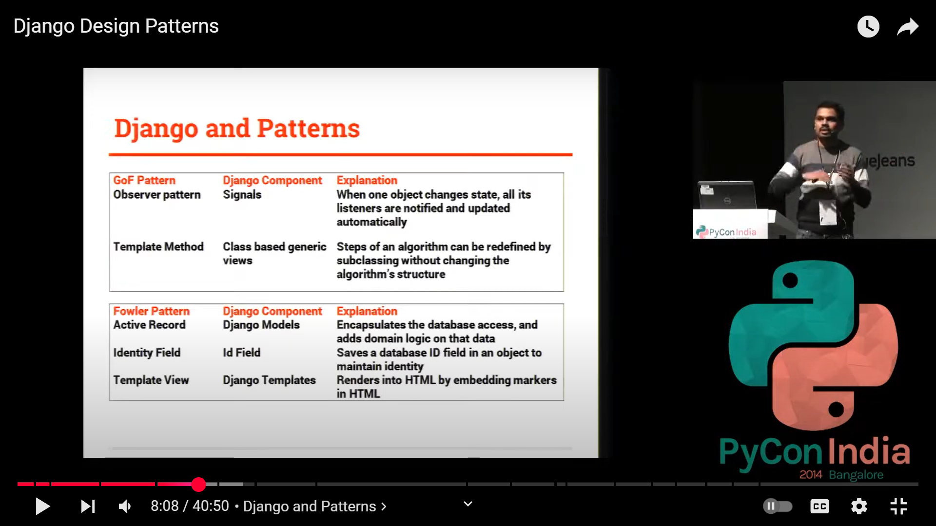

Django Follows MTV->

Model , Template , Views

1. Singleton Pattern
2. **Factory Pattern**
3. Observer Pattern
4. Decorator Pattern
5. Strategy Pattern
6. **Repository Pattern**
7. MVC / MTV Pattern